Healthy Eating Policy

As parents and educators, we are all very conscious of the importance of our children’s diet and how it impacts on their health, development and well-being. As children spend a significant part of the day in school, it is very important that they eat healthy, nutritious lunches. This is much easier to encourage when every child is eating nutritious food.
What people eat is known to be a key factor influencing health. Research indicates a strong link between diet and performance (e.g. low sugar intake promotes concentration, lessens hyperactivity, protects teeth, and lessens the risk of diabetes. A low salt intake reduces the risk of heart disease in later life).
To encourage this, we are working with the Parents’ Association to draw up our policy. The successful implementation of this policy is an important step in promoting a healthy lifestyle for the children.

All families and pupils are asked to co-operate with its implementation. The policy will be reviewed on a regular basis.

Aims
- To promote the personal development and well-being of the child
- To promote the health of the child and provide a foundation for healthy living in all its aspects.

Objectives
- To enable the child to appreciate the importance of good nutrition for growing and developing and staying healthy
- To enable the child to accept some personal responsibility for making wise food choices and adopting a healthy, balanced diet.
- To make children aware of the different food groups and the importance of each.

Healthy Lunch Choices:
- Bread and filled rolls, especially home-made
- Filled Sandwiches
- Pitta bread, naan bread, wraps, bagels
- Crackers
- Pasta, rice
- Cheese
- Meat
- Tuna, sardines, honey, jam, tinned salmon
- Salad
- Peeled carrot, celery, salads
- Bananas, oranges, apples, kiwi, nectarines, pears, strawberries etc
- Drinks- milk, water, homemade smoothies
The following website- http://www.safefood.eu/Education/Primary-(ROI).aspx provides some excellent advice for parents of primary school children on preparing healthy lunches for their children.

The following foods should not be included:
- Chocolate bars
- Biscuits and cakes
- Crisps, Pringles, Snax and related products
- Fizzy and sugary drinks
- Nuts ( due to concerns about choking and the possibility of some children having nut allergies in the school)
- Chewing gum
- Sweets and lollipops
- Popcorn, except on Friday (due to mess created in classrooms)
Yogurts
While the school acknowledges that yogurts, frubes and yogurt drinks can be a healthy option, we strongly advise parents not to send these as part of your child’s lunch. Some yogurts contain a very high amount of sugar. Also the rooms in the school are carpeted and spillages are a very common occurrence.

Fruit and Vegetable Breaks
The children will be allowed take a 5 minute break at 10.00 three mornings a week to eat a piece of fruit or veg. Only fruit and veg will be allowed at this time. The aim of this initiative is to encourage children to bring more fruit and veg to school and to allow them some extra time to eat it. It is also hoped that children will take more responsibility in the middle and senior classes for packing a piece of fruit and veg each morning before school for their fruit and veg break. Having a healthy snack at this time of day will help children to develop lifelong healthy eating habits.
Eating time
Time will be allowed for children to remain in class to eat lunch or food may be taken to the yard. The school has recently applied for our first Green Flag and as part of this process we encourage children to take home as much waste as possible with them in their lunchbox. We ask that children put wrappers and tin foil back in their lunch boxes and take these items home again. It has come to our attention that many children are in too much of a hurry to eat their lunch. They may be encouraged to eat if the lunch is prepared in a convenient manner and doesn’t require much effort to consume. Oranges should be peeled, especially for younger children.

Food Pyramid
The new Food Pyramid is a very convenient way for parents to decide on healthy choices for their children and can be found below.

A very simple approach to healthy eating is to use the Food Pyramid:

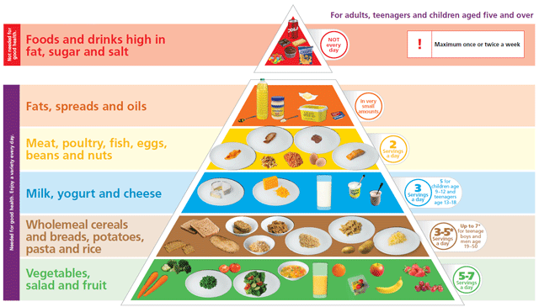

The Food Pyramid has recently been updated and now advises that children eat up to 5-7 servings of vegetables, salad and fruit each day. A guide to the new food pyramid can be found by clicking on the following link- Food Pyramid Guidelines.

Treats
From time to time teachers may give as a treat something which is not on the healthy list, as a celebration or as part of a festive occasion. It is important that the school should be notified if a child has a condition (such as diabetes) or a food allergy.

The school will also begin to use ‘Active Treats’ as a means of rewarding children in the school. For an active treat a class may be taken to the yard where they will have a choice of games or physical activity for a set period of time. The children will also be allowed use PE equipment such as hoola hoops, skipping ropes, rackets and balls for this active treat.

Every Friday the children will be allowed to bring a treat to school for lunch. We will use the Food Pyramid as a guide for these treats. Examples of treats according to the Pyramid include;
- 4 squares of chocolate
- 1 small cup cake/ 1 plain muffin
- 2 plain biscuits/ 1 chocolate biscuit
- 1 small bag of crisps/popcorn

A copy of this policy will be available to view on the school website

Signed:

_____________________
(Chairperson)

Date:
______________________

