St Molua’s NS, Ardagh, October 2022 Newsletter
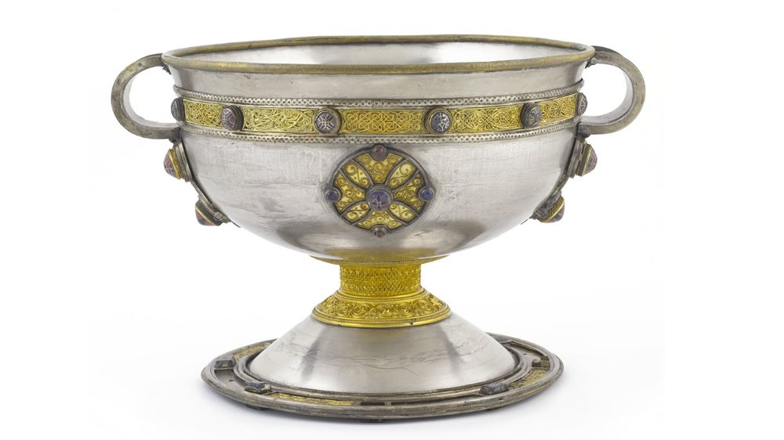
Welcome
The B.O.M. and staff of St. Molua’s N.S. would like to welcome all pupils and parents back to school for the 2022/2023 year. Apologies that we are a little late in communicating with you this year.
We would especially like to welcome our 16 new Junior Infants –Kurt, Mantas, Paddy, Donagh, Jonas, Matthew, Zac, Maebh, Aoibhinn, Theodore, Mikey, Tommy, John, Ava, Jamie and Victoria. We also wish to welcome back our Ukrainian pupils, Oleksandr, Artem, Vladislav, Anastoisia and Maxim. We look forward to a very busy and enjoyable school year.
We would also like to welcome Ms Wallace on board as our new Special Education teacher and wish Ms Scanlon well in her new role as Deputy Principal
Reminder
School begins each morning at 9.00 a.m. Children will be supervised from 8.45 a.m. onwards. If for some reason, you are delayed collecting your child from school, please phone to let us know.
New Building
The Department of Education has approved an extension to the school. The architect has been appointed and initial surveys are completed. The old prefabs will be replaced with a new building including 3 Special Education rooms for children receiving additional help. There will also be a new Special Education Needs Unit which will be in addition to the mainstream classrooms. This will include classrooms, toilets, multi-activity spaces and a sensory garden.

Art & Craft/Digital Learning
Thank you to all the parents who have paid the above fees. The money is used to finance photocopying in the school as well as the purchase of art and craft supplies. The digital learning fee is to pay for digital resources, which are becoming a really big feature of learning in all schools.
School Uniforms/Tracksuits
Children from 1st class up should wear their track suits on the days allocated to P.E. (including swimming) by their class teacher. Uniforms should be worn on all other days.
Please ensure that all clothes likely to be removed i.e., coats, hats, scarves, jumpers etc. are clearly labelled in bold writing with your child’s name on them. If the names become faded during the year, we ask you to replace these labels. As many children possess similar items of clothes this would reduce the loss of items. We currently have a substantial stock of unclaimed jumpers/sweatshirts. Please feel free to call in and check if any of them belong to your child.
Curriculum Initiatives
First and Second Class have taken on an initiative called Picker Pals. Taking it in turns, children take home the Picker Pack and lead their family on a litter-picking adventure in their local area. This is going really well – thanks to Ms Cronin, the children and parents for their contribution to the environment.
We have almost completed a 6-week programme of fitness with all classes. The classes are being provided by School Fitness Ireland every Monday with the emphasis on fitness in a fun way.
The children in 5th and 6th are currently swimming every Friday. We hope to continue swimming after Halloween for 1st to 4th class inclusive, provided that it is affordable. We will contact you further in relation to this.
Third and Fourth class recently attended an online interview with Katie O’Brien under an initiative called ‘Inspiring Ireland, Inspiring Students’. Katie O'Brien from Galway is a Para rower with her eyes and heart set on a gold medal at the Paralympics in Paris in 2024. Born with a severe case of spina bifida, which affected her left leg and parts of the left side of her body, she has excelled in rowing in recent years after picking up the sport in her mid-teens. She is also a qualified vet. The children were very inspired by Katie’s story.
Curious Minds is a STEM (Science, Technology, Engineering and Maths) Programme for Primary Schools. It replaces the Discover Primary Science for which we received 4 Awards. We are hoping to complete the training for this new programme this year with a view to implementing it thereafter.
We received a library book grant from the Department of Education for the coming year. We will be using this grant to enhance our current literacy resources in all classrooms and Special Education.
The children are currently preparing their entries for the Credit Union Art Competition. They also produced beautiful art work last year with our local artist, Lisa O’Sullivan. This amazing work is displayed in the school.
Football
The school is currently participating in the Boys Division 2 Football League. They have already played the Gaelscoil and will be playing Kilcolman next week. We have also registered for the Girl’s Competition which will commence at a later stage. In the meantime, the girls will be going to a football blitz in Mick Neville Park on Tuesday, October 18th. We are very proud of all our competitors.
Digital Learning
We have purchased a suite of 18 Chrome Books with a charging trolley. We have also updated our interactive whiteboards to the latest technology. We have installed fibre broadband and updated our wi-fi infrastructure to enable us to enhance digital learning. We are hoping to make great use of our Chrome Books across all curricular areas in the coming terms.
Internet Safety:
We would appreciate your support in speaking to your children about internet safety. Please note that the school does not agree with children using smart phones to communicate. It is our experience that using smartphones can negatively impact relationships, even if there is no intent to do so. We hope to provide the children with Cyber Safety Training online through the use of our new Chrome Books.
Healthy Eating
Pupils are expected to bring healthy lunches to school at all times. A treat is allowed on a Friday. Crisps, chewing gum, and fizzy drinks are not allowed at any time. The school appreciates your co-operation with this policy. Popcorn is only allowed on Friday’s due to issues with spillage.

Attendance
The school promotes good attendance by all pupils. If a pupil is absent, please use the Aladdin App to notify us of same. It is important the pupils return to school after appointments, where possible. The school rewards pupils with excellent attendance at the end of the school year.
The school is using the Aladdin school management system at present. This system automatically texts parents when your child misses 15 days. The school is obliged to report to TUSLA (Child & Family Agency) when a pupil misses 20 days in a school year.
Head Lice:
Please check your child’s head regularly for headlice. It is recommended to do this for school children using a fine comb, once a week. Tie back or braid long hair. If someone in your house has head lice, remember to check everyone else in the house. If you find head lice, please let us know immediately and treat your child with an over-the-counter treatment. Your pharmacist will advise you best on treatments.
Halloween Fun Day
Children are invited to dress up on Friday, October 28th, in their Halloween costumes. We would encourage you to consider home-made costumes with the use of recyclable materials, if possible. However, all costumes are very welcome. There will be prizes on the day. There will also be a raffle for a novelty cake.
Parent Teacher Meetings
Parent-Teacher meetings will take place on Thursday, November 24tn. We will be available from 8 am to 9 am and from 1.45 to 4.00 pm. We will communicate further in relation to times etc. in due course but we will do our very best to accommodate everyone in relation to times. Parents who requested a phone call instead of face-to-face will be accommodated also. If this date does not suit you at all, please contact us to discuss.

School Calendar – We have attached a calendar for your convenience.

